Resume
Of
TOPU SUTRADHAR

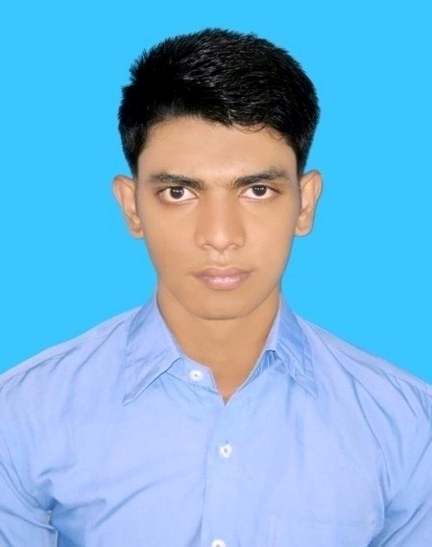
:
Mailing Address

Contact Number:  01837218372.
Rono-Milon Acharjee Bari,
(Acharjee Para)
Vill: North Kattali,
P.O: Pahartali,
P.S: Khulshi,
Dist: Chittagong.
Email: shopnonil.sutradhar@gmail.com

:
Career Objective

I would like to work in an environment of growth and excellence and earn a sound position in corporate world which provide me job satisfaction and self development and help me to active personal as well as organizational goals.

:
Academic profile

Name of exam | Concentration Major | Name of Institution | Result | Year of Passing | Duration
HSC | Business Studies | Bijoy Smarani University college, Chittagong | 3.40 | 2013 | 2011-2012
SSC | Science | Ramgarh Govt.High School, Chittagong | 3.50 | 2011 | 2009-2010
BBA | Ongoing Second Semester | Port City International University,Chittagong | ----- | ----- | 2014-2018

:
Computer Literacy

- Office Operation : Microsoft Office Word, Microsoft Office Excel, Microsoft Office power point.

- Web & Media, Internet Browsing.

☑ Please turn over

:
Language Proficiency:

- Good at Spoken and Writing in Bengali, English.

:
Extra Course

- Computer Application. ( Institution : Kattali Nurul Hoque Chowdhury Computer Complex’14)

- Spoken English Course. ( Institution : Executive’s Care Education
Foundation’11)

:
Personal Details

Name : Topu Sutradhar.

Father Name : Balay Sutradhar.

Mother Name : Bakul Rani Sutradhar.

Date of Birth : 15 November 1994.

Cell No : +8801837218372.

Marital Status : Unmarried.
Religion : Hindu.

Nationality : Bangladeshi By Birth.

Height : 6’’.

:
Permanent Address

Village : Garjantali.
Post Office : Ramgarh (4440).
Police Station : Ramgarh.
District : Khagrachari.

:
Reference:

- Apu Sutradhar
Co-ordinator of IGMIS College.
Contact No: +8801558451072
932/A, Mehidibagh, Dampara, Chittagong.

:
Announcement

I do hereby declare that, the materials provided here are true and no misinformation is given.

____________________
Signature

